Hyperinflation in Venezuela

A study on cause-effect with data analysis

***What is Hyperinflation?***

Hyperinflation is composed of two words: hyper which means extremely energetic and inflation which is a rise in the general price level of an economy. It is an economic situation where rapid, excessive and out of control growth of the general price level happens in an economy.

Inflation is common. The US has historically maintained 2 percent annual inflation.Hyperinflation is rare. There have been less than 60 documented cases in human history and is characterized by an inflation rate of more than 50 percent monthly i.e of the order 10 power 4 percent annually.

What this signifies is that if the price of wheat today is Rs.100/kg it has the potential to reach more than Rs. 10000/kg at the end of the year. If wages don't grow in the same proportions, the standard of living goes down because the populace can't keep up with their necessities. In many such economies people resort to hoarding because a general low level of trust prevails on the purchasing power of currency in their hand.

The worst cases of hyperinflation were seen in Europe during and after the two World Wars. In 1918, after the end of WW1, Germany under mounting debts and reparation costs witnessed an daily inflation rate of 21%. The German mark was even used by some as wallpapers because of the abysmally low purchasing power it held. Inflation in Hungary peaked in 1946 when it saw a daily inflation rate of 207%. Prices were doubling every 15 hours.The worst in recent years was Zimbabwe’s hyperinflation where daily rates went as high as 98% and the world saw the highest ever denomination of currency printed - one hundred trillion Zimbabwean dollars.

Although there had been instances before, Venezuela is currently the only country in the world experiencing hyperinflation.

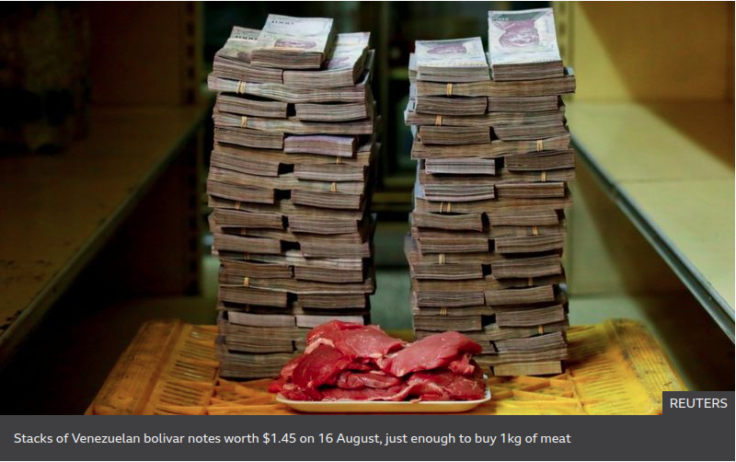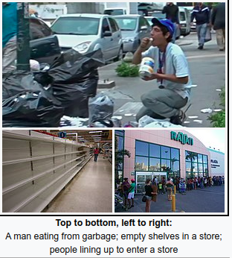

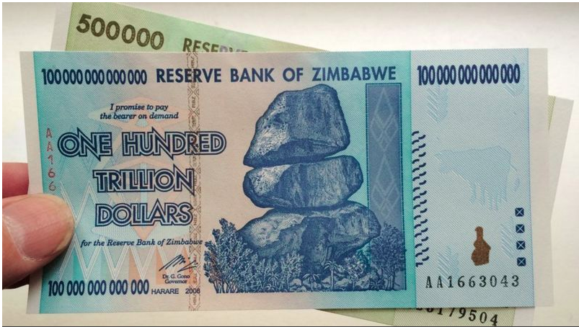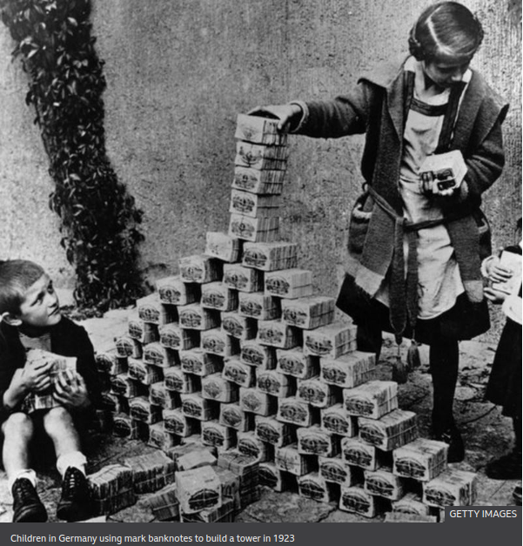

**Background: Venezuela’s economy**

The economy of Venezuela depends generally on the oil and assembling areas. Venezuela is the 6th biggest individual from OPEC by oil creation. Since the 1920s, Venezuela has been a rentier state, offering oil as its principle. The demonstrated oil holds in Venezuela are perceived as the biggest on the planet, adding up to 300 billion barrels more than that of Saudi Arabia which remains at the subsequent position.

After being chosen the President in 1998,Hugo Chavez drove different egalitarian social changes. With increasing oil prices in the 2000s and streaming funds [Bolivarian Missions](https://en.wikipedia.org/wiki/Bolivarian_Missions), aimed at providing public services to improve economic, cultural, and social conditions was founded. The Gini coefficient, a proportion of pay disparity, dropped from .495 of every 1998 to .39 out of 2011, placing Venezuela behind just Canada in the Western Hemisphere. Venezuelans matured 15 and more seasoned, 95% could likewise peruse and compose, with Venezuela having one of the most elevated proficiency rates in the locale. The GDP enlisted a four overlay increment by 2010 contrasted with levels in 2000.

These populist policies eventually created severe socio economic pressure in Venezuela. The economy relied heavily on oil revenues to fund large quantities of imports as opposed to development of domestic industries and technology. Production under Chavez’s regency declined owing to frequent price control measures and interventions. Many MNCs exited the nation for the same reason resulting in falling employment. By 2012, 96% of exports were centred around the petroleum industry according to the World Bank. The economy thus became very vulnerable to global oil price fluctuations.

Venezuela became a classic patient of the Dutch disease, a disease wherein the country's resources turn into its curse. The instrument is that as income flows in the developing sector, the country's currency appreciates. In such a scenario the country's other exports become more expensive compared to imports, making those domains less likely candidates of development and investment. Countries with economies based on large resources of gold and oil are generally susceptible to the Dutch Disease.

With Chavez’s death in 2013 and President Nicolas Maduro’s ascent the situation remained the same. Maduro strictly followed the same policies like his predecessor to garner public support.

**Data Analysis**

Moving further with the case of Venezuela, I will support my arguments based on freely available data published by the World Bank and the International Monetary Fund.

I performed some data analytics on the umpteen macroeconomic variables archived by the World Bank. I have extensively used the Pandas library of Python for analysis which is easily accessible and comprehensible through its documentation. Graphs have been plotted with the help of Seaborn and Matplotlib libraries which are widely used for data manipulation in the industry.

Steps involved in the wrangling of data;

* Aligned world bank data to comply with Pandas Dataframe standards.
* Removed duplicates i.e. fields that had the same value but in different units( in percentage and LCU(Local Currency Unit) and USD).
* Deleted fields with redundant (with respect to our current analysis) information. For example population and mortality rates had fields for different age groups as well with different genders.
* By the above steps, the number of fields was brought down to 200s form 1400s

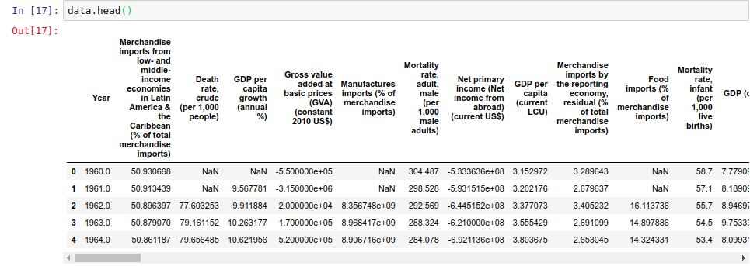

After cleansing the fetched data, I plotted time series trends of the particular macroeconomic variables. All the trends below have time in years in the x-axis and various macroeconomic variables in the y- axis. Since World Bank data for Venezuela originates in the year 1960, X-axis contains years between 1960 and 2018

|  |  |
| --- | --- |
|  |  |
| The blue curve above represents the fuel exports as % of GDP. Similarly, the red curve represents net fuel imports as % of GDP.  It can be easily inferred that Venezuela is an oil-based economy. Fuel exports have contributed to an average 88% of GDP over the years with the the 2000s | The curve above is that of Trade-to-GDP ratio. It indicates the relative importance of international trade in the economy of a country.  Venezuela’s Trade-to-GDP fluctuates largely with global oil prices. It is currently going through one of its lowest phases in the last twenty years. |

|  |  |
| --- | --- |
|  |  |
| Broad-money growth indicator gives an idea of total money supply in the economy.  The steep rise in broad-money growth signifies excessive money-printing, a fundamental cause of hyperinflation. | Total reserves in gold and foreign currency denote the backing available to balance payments of the economy and to maintain confidence in financial markets.  Dwindling reserves has made foreign investors cautious of investing in Venezuela. |

|  |  |
| --- | --- |
|  |  |
| Wholesale price index is one of the most common indicators of inflation in an economy.  Venezuela for most of the twentieth century maintained a low rate of inflation. The almost vertical line after 2014 signifies the explosive inflation rate witnessed by Venezuela and is the topic of our discussion. | Mortality rate of a nation gives away its score on human rights and health. It also is correlated to the crime rate of the nation.  A decreasing mortality rate indicates a better healthcare system and lowering crime rate. But beyond 2010, there is a sharp increase in mortality rate which is attributed both to more crime and greater police violence in subduing crimes. |

Below I have plotted some more interesting trends. These will not be discussed in detail in the present scope but provide great insights and are open to more research.

|  |  |
| --- | --- |
|  |  |
| Government Final Consumption Expenditure | Fertility rate among women aged 15-18 |
|  |  |
| Military Expenditure (% of GDP) | GDP per capita |

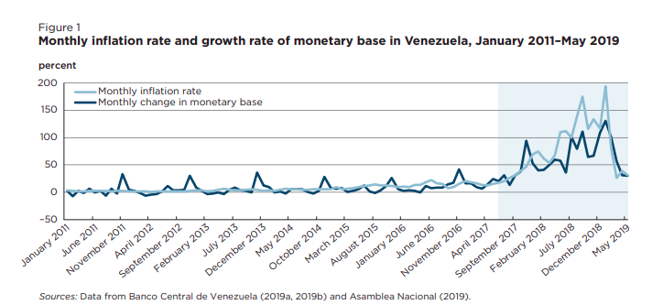

The plot on the left depicts monthly inflation rate as published by the Central Bank of Venezuela. I could not explore other data published by the Central Bank of Venezuela because the metadata was in Spanish.

## Pearson Correlation Coefficient Heatmap in the Long Run (1960-Present)

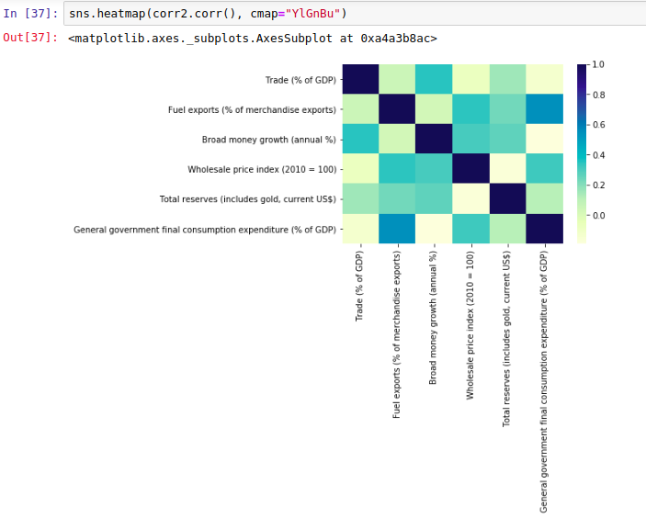

Very dark boxes and very light boxes symbolize strong positive and strong negative correlations respectively.

From the Heatmap, no strong correlations can be found. In the long run all the macro economic variables performed almost independently of each other.

We will now move on to the short run correlation heatmap which is more provoking.

## 

## Pearson Correlation Coefficient Heatmap in the Short Run (2010-Present)

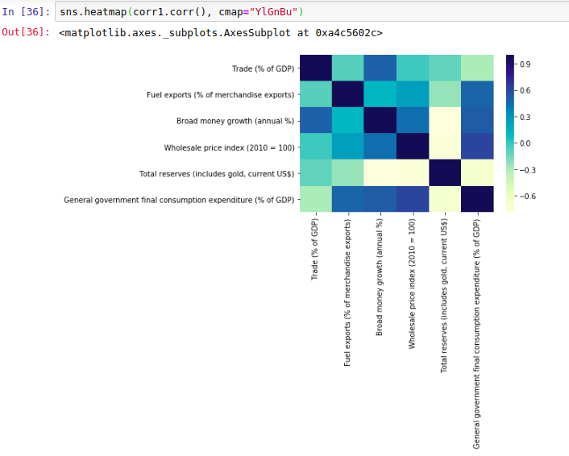

In the short run, one can spot many correlations. Most intriguing among them is the correlation between wholesale price index and total reserves.

Total reserves have fallen strongly with growth in Broad Money with a correlation coefficient of -0.78

Also, government final consumption expenditure moves in the same direction as Wholesale Price Index with a correlation coefficient of 0.72

**Causes And Effects**

The oil glut of the 2010s that occurred because of better fracking technologies in the US and Canada became the trigger point for the hyperinflation.Government policies further escalated and aggravated the economic crisis and subdued reversion back to the normal GDP.

* **Excessive money supply:**

The reaction to a depression is typically an expansion in the cash by the national bank. The additional cash is intended to urge banks to loan to shoppers and organizations to increase spending and speculation. Government attempts to adjust its deficiency by hard money- printing to combat depression.

In any case, if the expansion in cash isn't upheld by financial development as estimated by (GDP), the outcome can prompt excessive inflation. In the event that GDP isn't developing, organizations raise costs to help benefits and remain above water. Since purchasers have more cash, they follow through on the greater expenses, which prompts swelling. As the economy crumbles further, organizations charge more, purchasers pay more, and the national bank prints more cash — prompting an endless loop and out of control inflation.

* **Devaluation of the Bolivar(currency of Venezuela):**

Devaluation of the currency in an economy primarily boosts production. It has two facets : A) it makes imports more expensive driving the consumers away from imported goods. At the same time it makes exports cheaper providing an impulse to domestic production. The (X-M) factor in national income accounting thus increases.

But for a successful implementation, devaluation must be backed with solid production facilities for satisfying aggregate demand. In the case of Venezuela, due to inefficient economic measures under the current President Maduro's reign, this led to widespread shortages and people resorted to hoarding.

* **Minimum wage**

Government intervention in the form of upholding minimum wages led to lower rates of investment. Populist but investor-averse decisions like these exacerbated the crisis in Venezuela. Most economists advised that the measure would only help temporarily due to the already high inflation rate and that the wage increase would only make things more difficult for companies, since they already faced money-crunch.

There were at least five minimum wage increments during the current President's reign in addition to the continuous social welfare schemes and food voucher distribution when the country faced larger problems. These resolutions depleted foreign and domestic reserves when economists suggested investment expenditure to increase aggregate supply and production.

An interesting observation is how government data is suddenly non-existent for most macro variables after 2016. Almost all trends after 2016 when Venezuela’s hyperinflationary began are predictions by the IMF and World Bank. The Maduro government has been infamous for silencing political opposition and extrajudicial killings of political and economical dissents. Hyperinflation and such government processes have led to Venezuela being the crime capital of the world. The effects of hyperinflation are as such:

* **Unemployment :**

The unemployment rate as measured in January 2016 was 18.1 percent and it featured at the bottom-most spot in the World Misery Index. Venezuela has not detailed any authority-accepted figures since April 2016, when the rate was at 7.3 percent.

Because of the inflation and confiscations by the Venezuelan government to privately owned businesses, numerous others left the nation, which furthered joblessness for those left. Moreover, the compensation increment toward the finish of 2016 resulted in dismissal of half the employed from large companies. Joblessness was estimated at 44% for 2019; the IMF expressed that this was the highest observed unemployment since the finish of the Bosnian War in 1995

* **Shortages** :

Strict import regulation and low aggregate supply has led to many shortages in Venezuela. Towards late 2015, it was assessed there was a deficiency of over 75% of merchandise in Venezuela. In March 2016, it was assessed that 87% of Venezuelans were consuming less because of the deficiencies. By December 2016, 78% of Venezuelans had shed pounds because of absence of food.Shortages of drugs reached a staggering 85% by January 2017, as per the Pharmaceutical Federation of Venezuela

Because of the deficiencies and price controls measures, arbitrage opportunities sprang in Venezuela. For instance, products subsidized by the Venezuelan government were snuck out of the nation and sold for a profit. Hoarding additionally aggravated paucity as Venezuelan shoppers developed anxiety over the recurring shortages.

* **Mass exodus of working age people:**

At first, upper-class Venezuelans and researchers emigrated during Chávez's administration, yet middle and lower-class Venezuelans started to leave as conditions exacerbated in the nation. There has been considerable brain drain as the educated individuals leave the country depriving it of future industry ready labour.

The UN anticipated that at its climax, there would have been more than 5 million recorded exiled people during the Venezuelan emergency over 15% of the populace living in 2019.

Evaluations going into 2020 proposed that the quantity of Venezuelan refugees was surpassing the 6 million figures, more than the total displaced by the Syrian Civil War (which has the general consensus of being the worst humanitarian calamity on the planet). The brain drain and simultaneous exodus of opposition has also led to more support for Maduro.

**Discussion: The path forward**

Although Maduro has recently receded back from his previous stance in late 2019, trust in the government remains at all time low. Venezuela is moving towards dollarizing its economy, a means which has been successfully implemented by Zimbabwe to arrest hyperinflation. USD is accepted currency in Venezuela but the government has decided not to do away with Bolivar.

In the following section I would discuss the strategies proposed by the classical and the Keynesian model to cut through hyperinflation. Disinflation means the process of reducing inflation rate by reducing growth rate of money supply. Thus, the basic method of disinflation is to reduce the growth rate of AD by decreasing the growth rate of money supply.

**The two alternative strategies used by the monetary authorities are:**

I. Gradualism. II. Cold Turkey.

I. Gradualism(from Keynesian model)

A policy of gradualism attempts a slow and steady return to low inflation. The government reduces the growth rate of money gradually over a period of years until it reaches the real growth rate of the economy and thus is able to stabilize inflation.

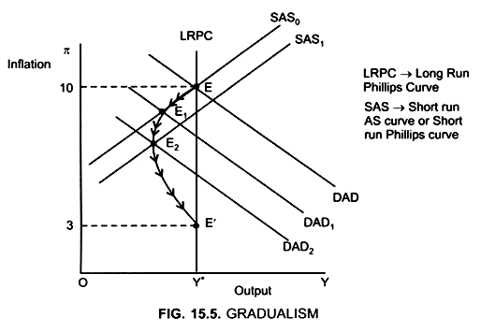

Initially the Economy is in equilibrium at E (Fig. 15.5)

At point E → DAD = SAS | Inflation rate → 10% | Output is at full employment level → Y*

If the monetary authorities reduce the money growth rate by a small amount, the AD curve shifts downward from DAD to DAD1. With SAS constant at SAS0 Economy moves from point E to E1.

At point E1 → DAD1 = SAS | Inflation rate decreases to π1

There is a small recession because the output falls below the potential level (full employment level). Due to the decrease in the inflation rate, people expect that the inflation rate will fall further and as a result, the SAS curve shifts downwards to SAS1.

Similarly, a further cut in money growth moves the economy from E1 to E2 (DAD2 = SAS1) where the inflation rate is still lower and this leads to further downward shift in the SAS curve. This process will continue till the economy reaches the potential level at point E’ at a lower inflation rate.

At point E’ → Inflation rate is lowered to 3%

**II. Cold Turkey(using Classical model)**

The cold turkey strategy tries to reduce the inflation rate rapidly by reducing the money growth by a large amount.

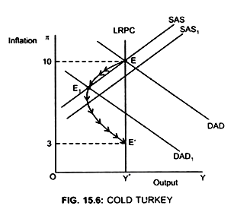

Initially the economy is in equilibrium at point E (Fig. 15.6)

At point E → DAD = SAS | Inflation rate → 10% | Output level is → Y*

To reduce inflation rate money growth is reduced by a large amount.

DAD0 shifts downwards to DAD1 | Economy moves from point E to point E1 at point E1, DAD1 = SAS

Inflation rate is lowered drastically to π1 but is accompanied by a considerable recession. This recession is larger than under gradualism. Due to large fall in inflation rate, the SAS curve shifts downwards to SAS . The decrease in money growth continues till the economy reaches point E’, that is at potential level and inflation rate of 3%.

So, the fall in inflation rate is faster in cold turkey, as SAS shifts down faster than in gradualism.

**Lesson from Brazil**

Brazil, neighbour of Venezuela and the fifth largest nation in the world, witnessed a similar hyperinflationary crisis in the 1990s. Given the same ethnicity and shared culture of Venezuela and Brazil, Brazil’s paradigm shift from the hyperinflation in 1994 by strong leadership at the helm and the induction of ‘The Real Plan’ is a must learn lesson for Venezuela.

A key highlight of Brazil’s retaliation was the denial of dollarization of the economy. By doing this, Brazil defended its future scope for regulating its monetary activities. At a point when a nation has completely dollarized, it gets subject to the impulses of the Fed – if the U.S. national bank raises loan fees, financial conditions will be fixed both in the United States and in the nation that has chosen to dollarize.

On the off chance if the nation is confronting a downturn, it would have been ideally serviced by free, not tight, financial arrangement. Furthermore, dollarized nations don't have authority over their trade rates since they at this point don't have their own monetary forms. Consequently, if they might want to devalue to boost exports they can't do as such.

According to ‘The Real Plan’, Brazil introduced a virtual currency, dubbed the URV, or “unidade real de valor” (“real unit of value”). The notion was that price levels in URVs would remain moderately stable consistently while local currency, cruzeiros were all the while rising. It was a sort of transitory instrument that identified out of control inflation was a problem of behavioural economics as well.

When enough trust in the URV had been set up; the cruzeiro was abolished, and the URV turned into the genuine, which is Brazil's currency till today.

The arrangement was a triumph, as inflation tumbled from a month to month pace of 45% in March and April 1994 to only 2% in July, the month the local currency was dispatched. Inflation in Brazil has been generally in single digits from that point onward.

**References:**

* [**Hyperinflation in Venezuela : Wikipedia**](https://en.wikipedia.org/wiki/Hyperinflation_in_Venezuela#Devaluation_of_the_bol%C3%ADvar)
* [**Stabilization handbook**](https://www.piie.com/sites/default/files/documents/pb19-13.pdf)
* [**How Hunger fuels crime in Venezuela**](https://time.com/longform/hunger-crime-violence-venezuela/)
* [**How to end a Hyperinflation**](https://www.economicsdiscussion.net/inflation/how-to-end-a-hyperinflation-2-methods/3061)
* [**The problem with printing money - Economics Help**](https://www.economicshelp.org/blog/634/economics/the-problem-with-printing-money/)
* [**How to Stop Venezuela’s Hyperinflation? Brazil Offers an Idea.**](https://www.americasquarterly.org/article/how-to-stop-venezuelas-hyperinflation-brazil-offers-an-idea/)
* **Macroeconomic Analysis by Edward Shapiro**

**Data Sources:**

* [**Venezuela, RB | Data**](https://data.worldbank.org/country/VE)
* [**República Bolivariana de Venezuela and the IMF**](https://www.imf.org/en/Countries/VEN#whatsnew)

**Link to the code used for data analysis:**

* [**https://github.com/munditva/QClub-backtesting**](https://github.com/munditva/QClub-backtesting)